Pružina zadná FeliciaKombiVW

Pictures for car part VOLKSWAGEN 6U9 511 115 A
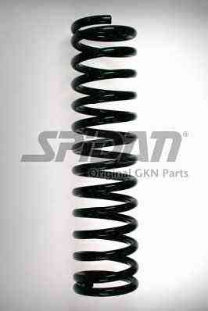

Analogous \ Similar Parts of VOLKSWAGEN 6U9 511 115 A
Manufacturer | Number | Description
MONROE | SP1844 | Coil Spring
SACHS | 996 659 | Coil Spring
SKODA | 6U9 511 115 A | Coil Spring
SPIDAN | 55008 | Coil Spring
SUPLEX | 31022 | Coil Spring

